**Saraf Abhinav**

**2420090058  
section 2**

**LAB 4**

**Construction of Different VLANs and Trunking using Cisco Packet Tracer**

**Step 1: Launch Cisco Packet Tracer**

Open Cisco Packet Tracer from your desktop or applications list.

**Step 2: Create the Network Topology**

**1. Add Devices:**

* Switches: Add two switches (S1 and S2).
* PCs: Add 8 PCs.
* Connections:
  + Connect PC0, PC1, PC2, PC3 to S1.
  + Connect PC4, PC5, PC6, PC7 to S2.
  + Connect Fa0/24 of S1 to Fa0/24 of S2 using a Cross-Over cable.

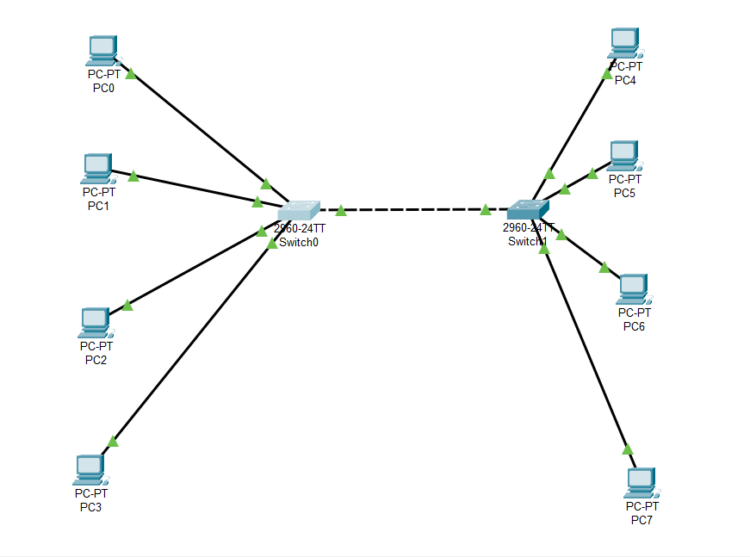

**Step 2:** VLAN Creation on Switches

**On Switch 0 (S0)**

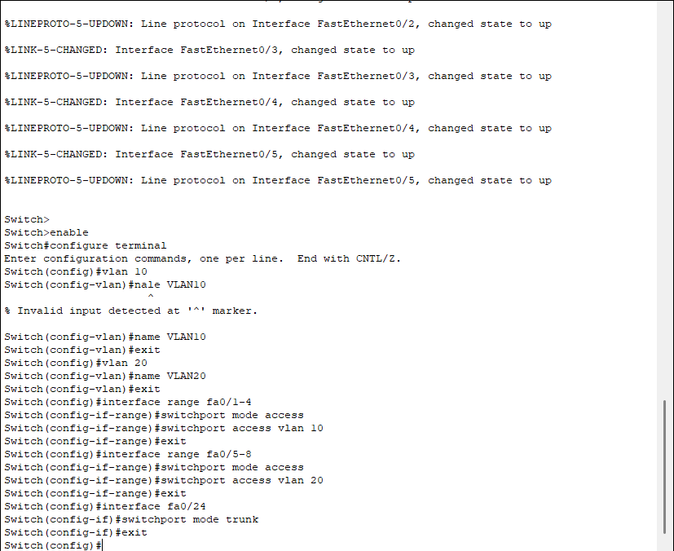

**On Switch 1 (S1)**



**Step 3:** Assign Ports to VLANs

**On S0**

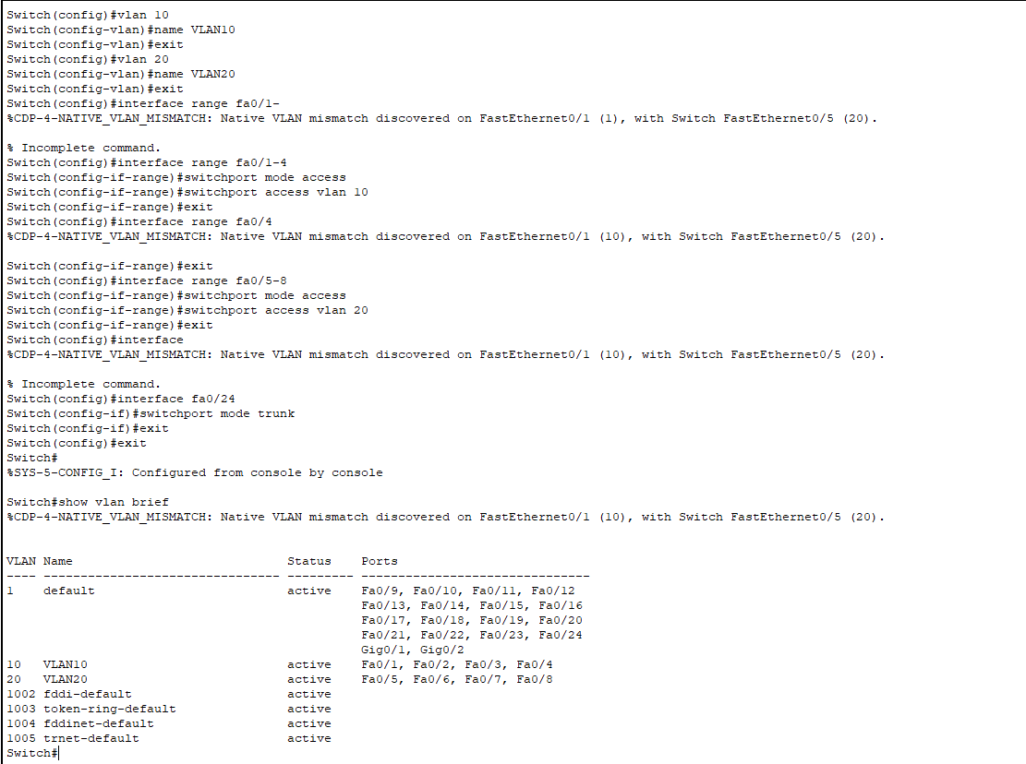

**On S1**



**Step 4:** Configure Trunk Ports

**On S1 and S2**



**Step 5:** Assign IP Addresses to PCs

| **PC** | **IP Address** | **Subnet Mask** | **VLAN** |
| --- | --- | --- | --- |
| PC1 | 192.168.10.1 | 255.255.255.0 | 10 |
| PC2 | 192.168.10.2 | 255.255.255.0 | 10 |
| PC3 | 192.168.20.1 | 255.255.255.0 | 20 |
| PC4 | 192.168.20.2 | 255.255.255.0 | 20 |
| PC5 | 192.168.10.3 | 255.255.255.0 | 10 |
| PC6 | 192.168.10.4 | 255.255.255.0 | 10 |
| PC7 | 192.168.20.3 | 255.255.255.0 | 20 |
| PC8 | 192.168.20.4 | 255.255.255.0 | 20 |

**Step 6:** Testing Connectivity

* **Within VLANs:**
  + Ping PC1 → PC2 (VLAN 10, same switch)

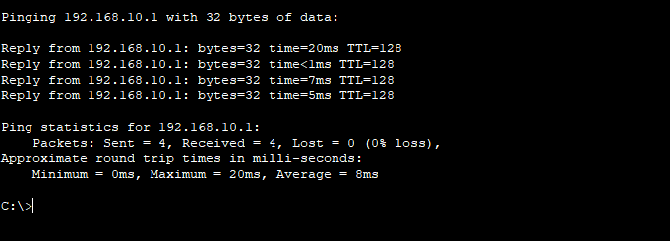

* + Ping PC5 → PC1 (VLAN 10, different switches)
  + Ping PC3 → PC4 (VLAN 20, same switch)
  + Ping PC7 → PC3 (VLAN 20, different switches)
* **Between VLANs (should fail without router):**
  + Ping PC1 → PC3
  + Ping PC7 → PC1

**Result:**  
VLANs were successfully created on both switches, trunking was configured, and communication was verified within the same VLAN across switches, while inter-VLAN communication was blocked without a router.